**Interior Border Gateway Protocol Lab**

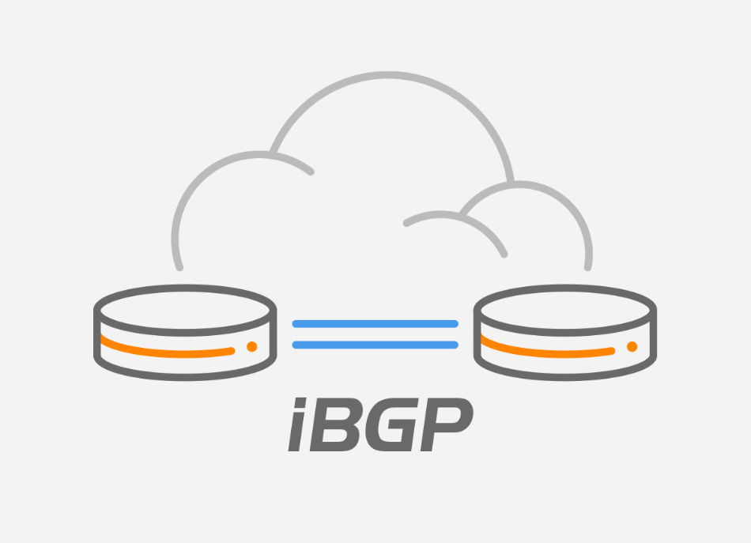

Charlie Qu

Period 0-2

Mason/Hansen

4/17/2024

Interior Border Gateway Protocol Lab

Purpose:

The objective of this lab is to set up the Internal BGP routing protocol within a network topology and to test its functionality by using show commands and ensuring that pings successfully traverse the entire topology.

Background Information:

BGP, short for Border Gateway Protocol, is a routing protocol that facilitates the exchange of routing information between different autonomous systems, typically on the internet. BGP encompasses two main types: eBGP and iBGP. Here is a breakdown of the key differences between these two sub-protocols:

* iBGP involves routing connections between routers within the same autonomous system, whereas eBGP operates between routers in different autonomous systems.
* This distinction means that eBGP is employed for routing traffic between distinct systems, while iBGP handles routing within the same system.
* To prevent routing loops, eBGP reduces the TTL (time to live) of each forwarded packet, whereas iBGP does not need to decrease TTL because it operates within a single autonomous system.
* iBGP is typically managed internally within an organization, whereas eBGP configurations often involve coordination between different organizations or ISPs, as it handles external internet traffic.
* In iBGP, the next hop address remains the same when routes are advertised to peers, but in eBGP, the next hop is changed to the IP address of the advertising router, often referred to as the "local router."
* Route reflection is used in iBGP but not in eBGP.
* Unlike iBGP, eBGP does not require a full mesh network topology.
* Given these characteristics, one might wonder why BGP is preferred over other protocols like OSPF. Here are some reasons:
* BGP supports more complex and hierarchical network structures, making it suitable for large enterprises.

While OSPF is generally used for intra-domain routing within a single autonomous system, BGP handles both internal (iBGP) and external (eBGP) routing across organizational boundaries. BGP offers more detailed control over routing decisions, allowing network engineers to manipulate factors like AS path and local preferences, providing a level of customization not as readily available in OSPF. Thus, BGP, with its dual capabilities of iBGP and eBGP, is highly favored for routing in large-scale corporate environments due to its ability to support complex network architectures and provide granular traffic management. This makes BGP a top choice for enterprises that require sophisticated routing solutions.

Lab Summary:

Draw a network diagram. Set up the IP configuration and basic settings on network devices. Implement necessary routing protocols. Redistribute routing information as needed. Check that iBGP is properly set up and working by using commands like "show ip bgp summary", "show ip bgp neighbors", and "show ip route." Conduct a ping test to ensure complete connectivity throughout the network.

Lab Commands:

* Use the command **neighbor [ip-address] update-source [interface]** to set up a neighbor relationship and configure iBGP using an interface address.
* The command **show ip bgp summary** provides a condensed overview of the BGP connection status and also shows the contents of the BGP routing table.
* To check whether a BGP peer connection has been successfully established and to view details about the BGP links, use the command **show ip bgp neighbors**.

Network Diagram:

Configurations:

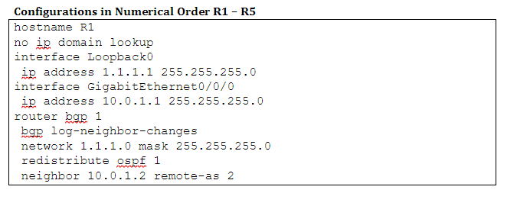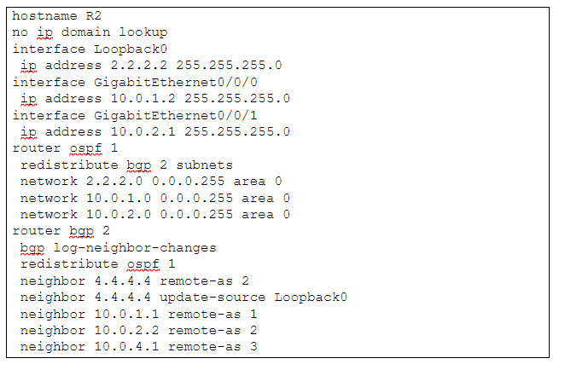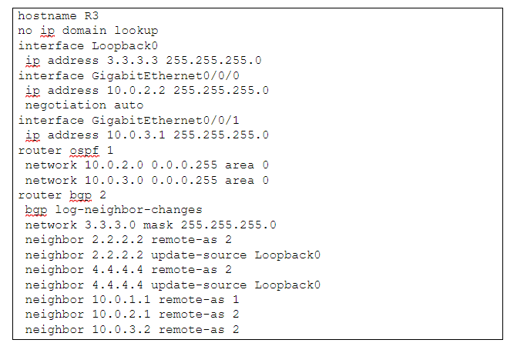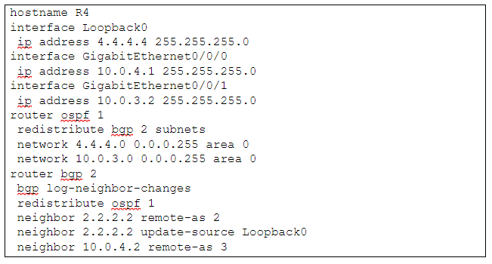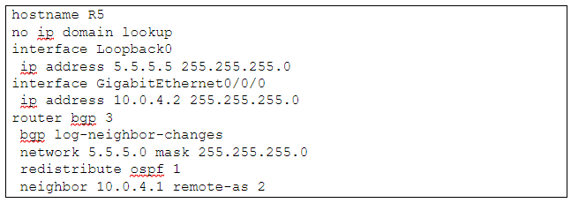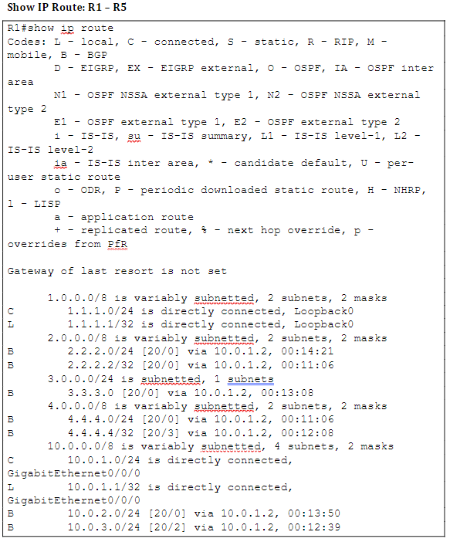

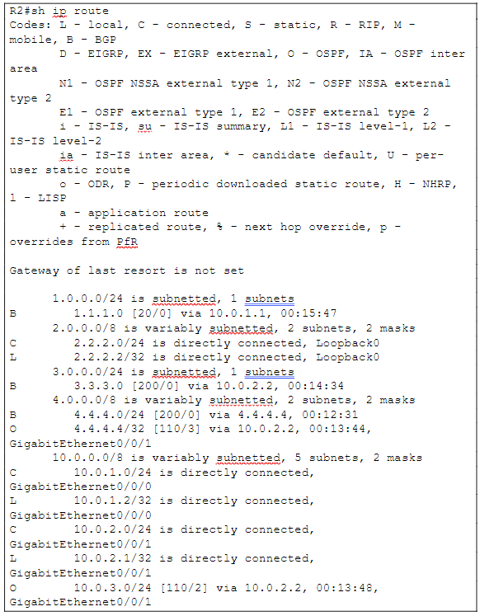

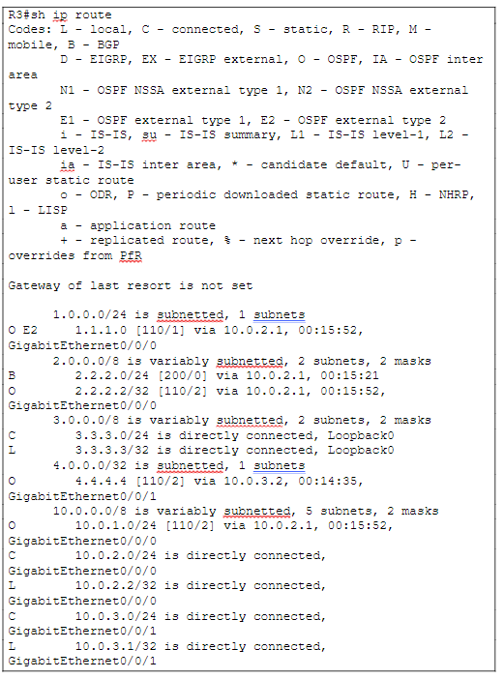

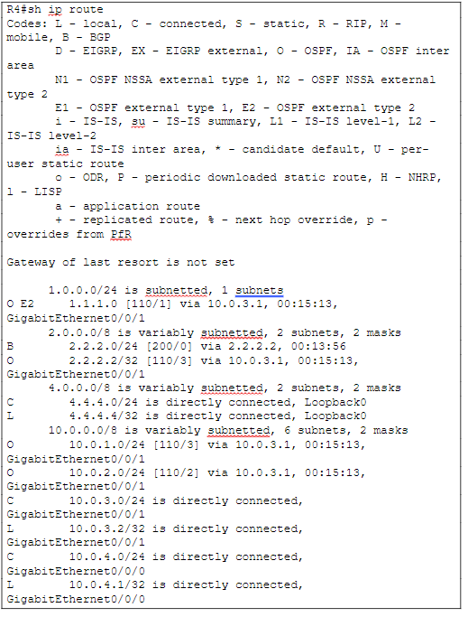

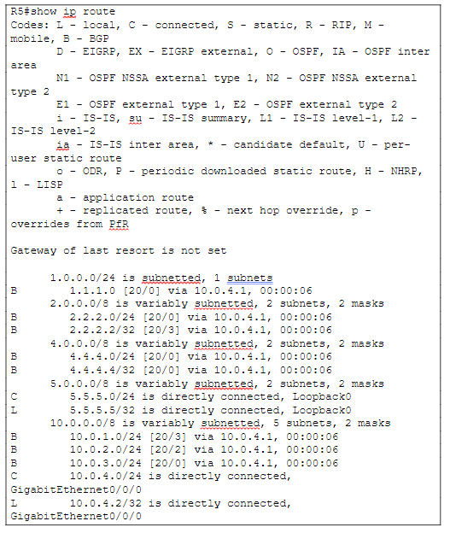

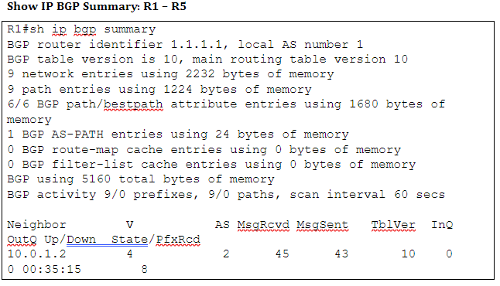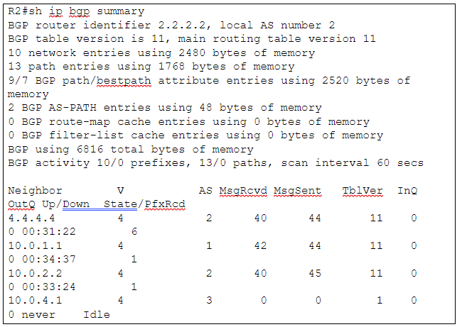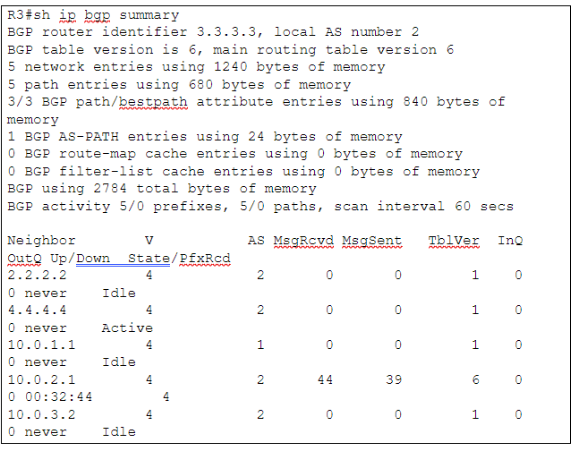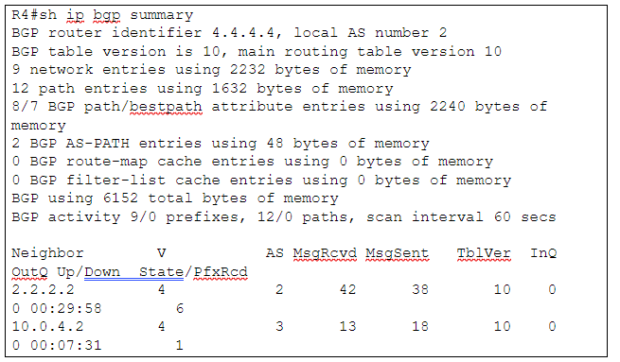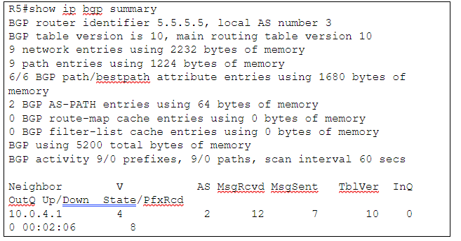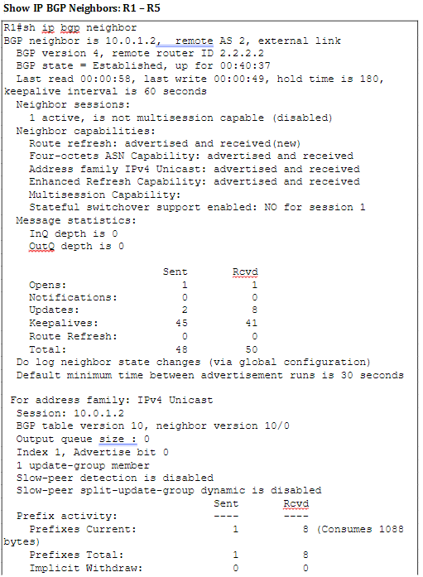

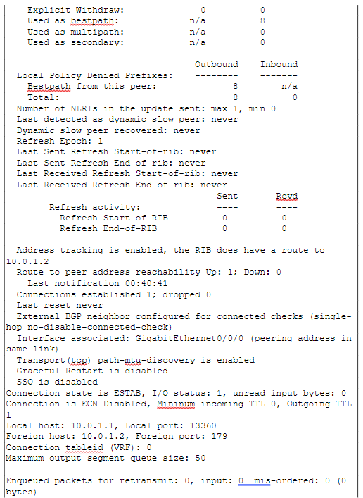

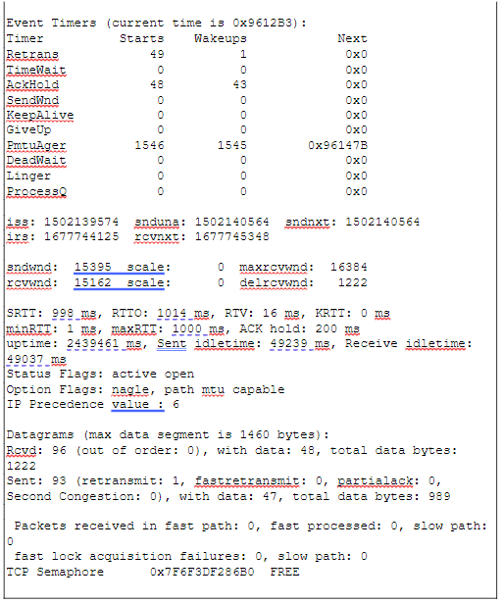

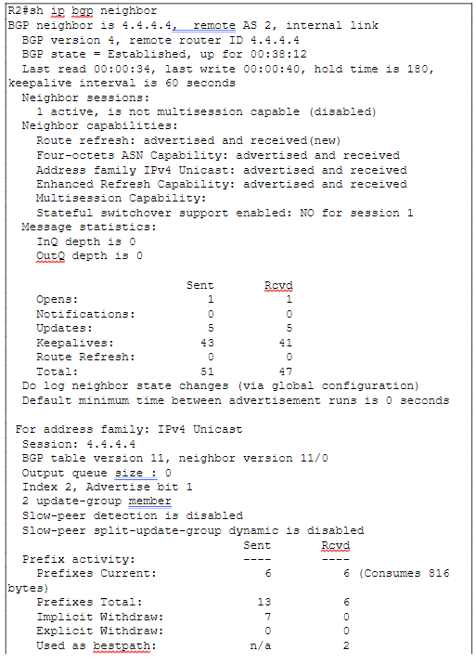

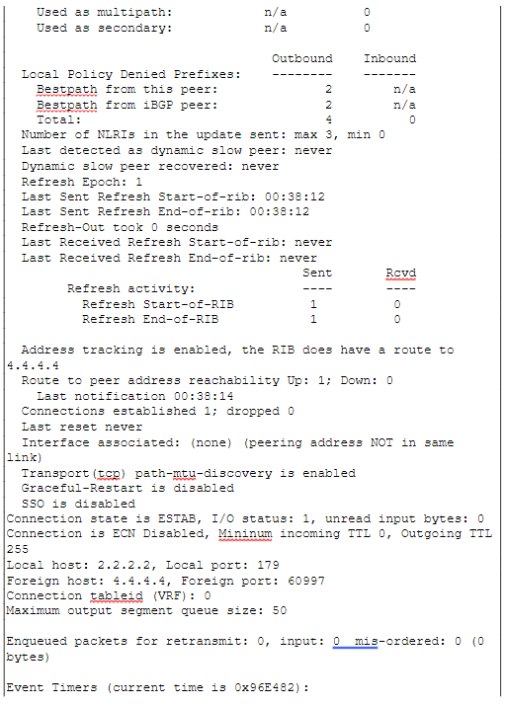

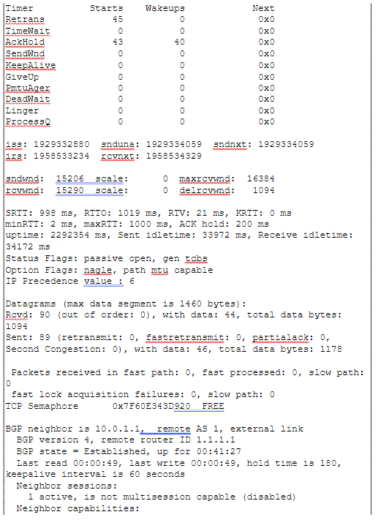

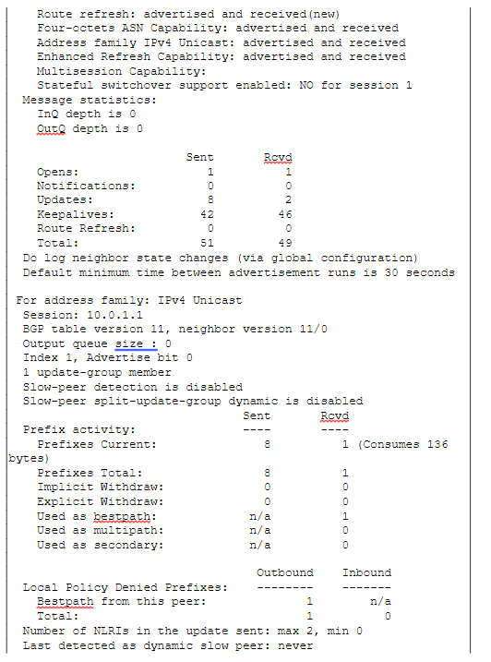

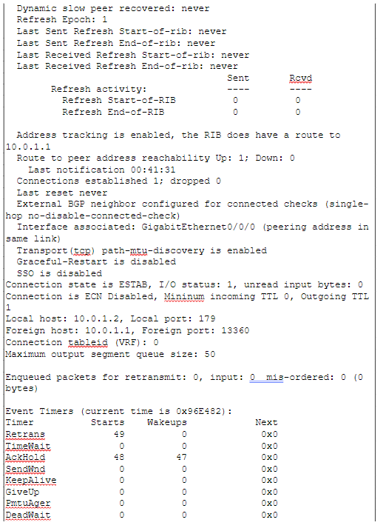

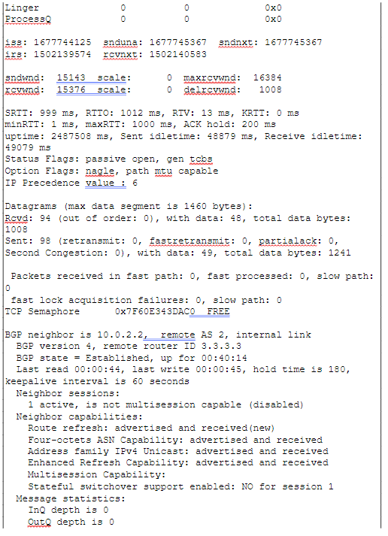

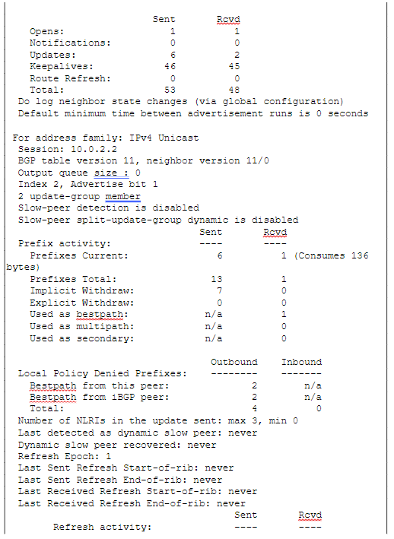

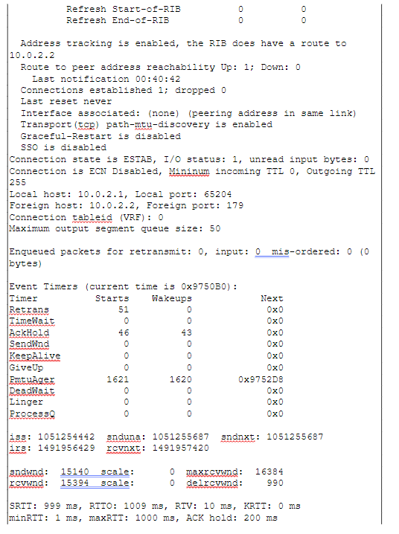

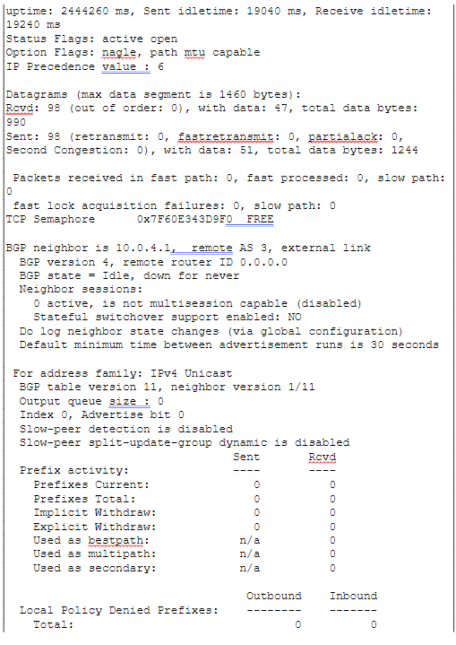

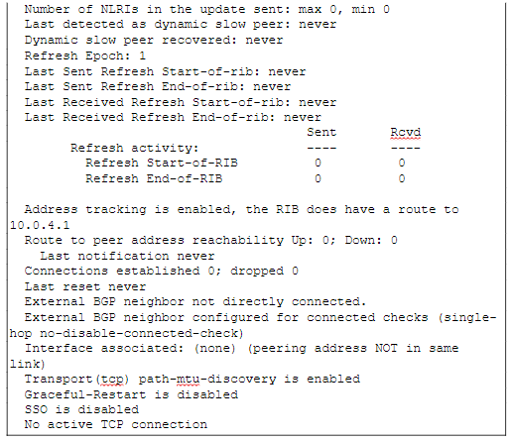

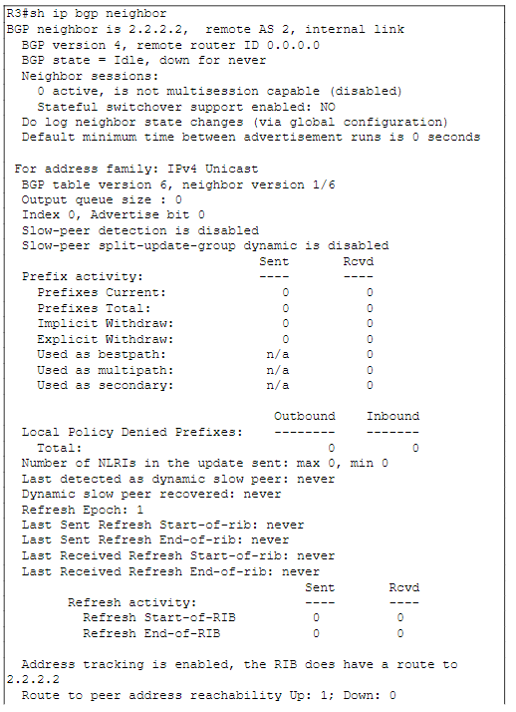

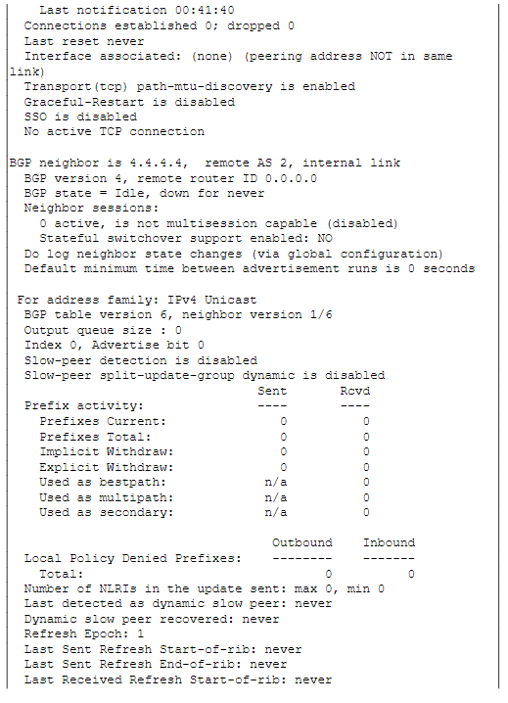

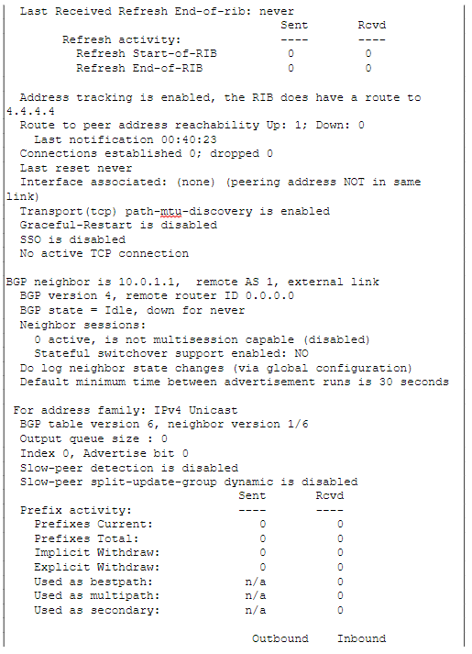

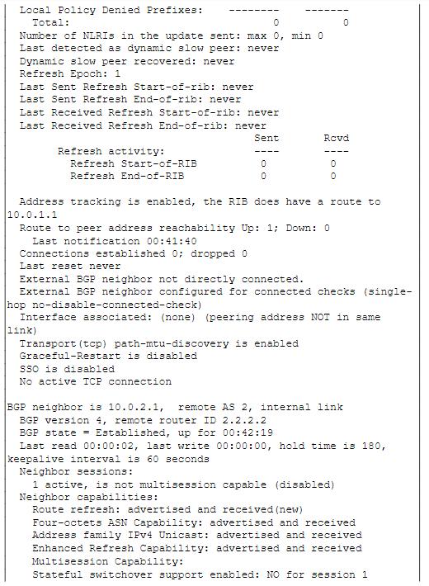

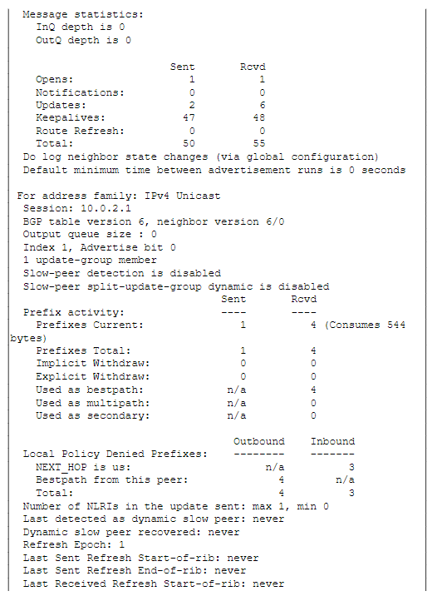

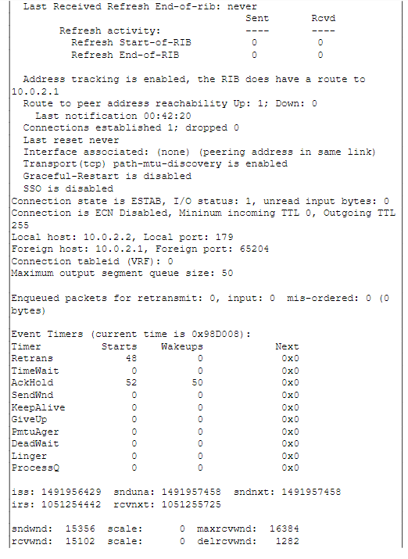

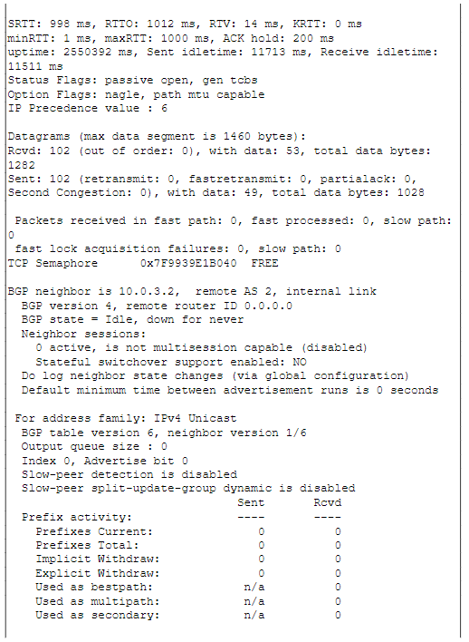

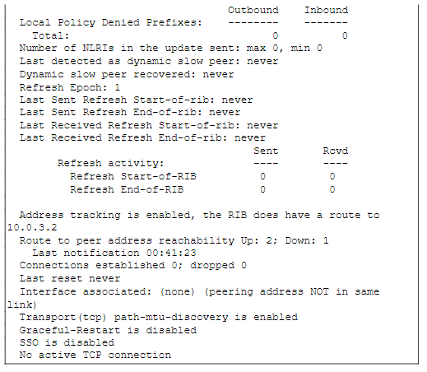

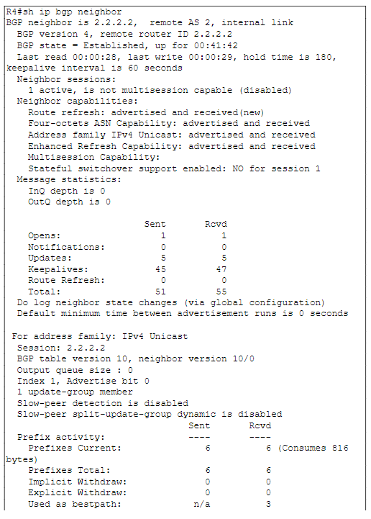

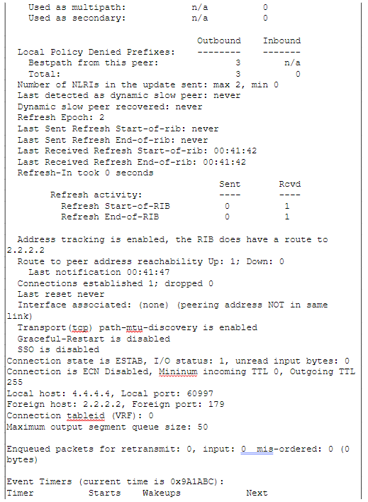

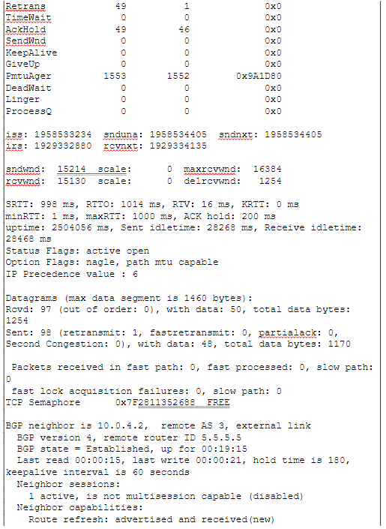

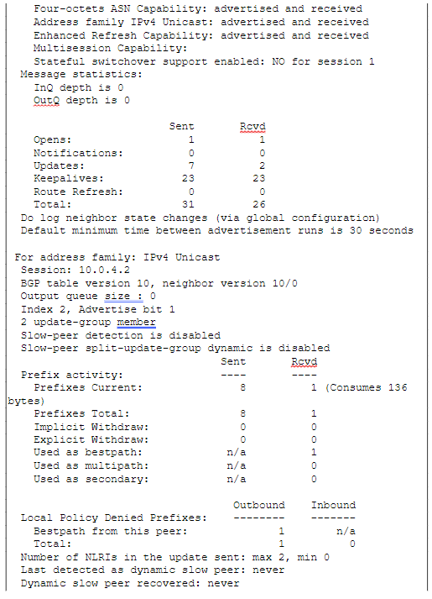

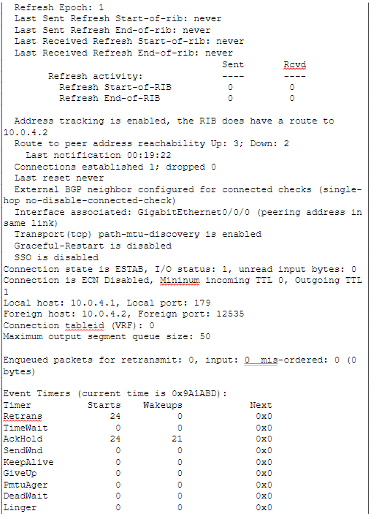

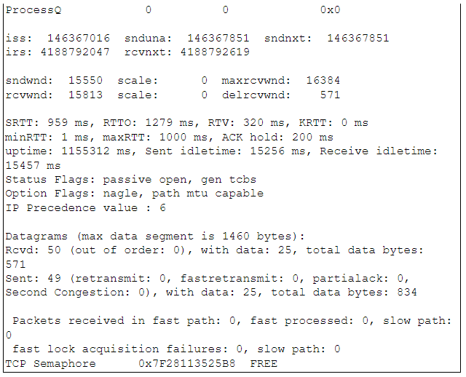

Problems:

In this lab, we encountered significant challenges in achieving complete network connectivity across the topology. Finding similar issues documented online proved difficult, prompting us to rely on debugging commands such as “show ip bgp summary” and “show ip route” to better understand the behavior and status of our routes. Upon detailed inspection, we noticed that OSPF was not fully redistributed on routers 2 and 3. Similarly, we hadn't redistributed all our BGP routes on routers 1 and 5. After adjusting the route redistribution on these routers, we observed improved connectivity; however, pings still failed to traverse the entire network. This issue was traced back to incomplete neighbor configurations on routers 3 and 4, which interrupted full connectivity. Identifying this problem required a thorough review of our entire network setup and routing configurations. Additionally, we discovered a typo in one of our neighbor configurations: we incorrectly set up **neighbor 10.0.3.2 remote-as 1**, whereas it should have been **neighbor 10.0.3.2 remote-as 2**. Correcting this error was a crucial but initially overlooked step in resolving our connectivity issues.

Conclusion:

In this lab exercise, I grasped the significance of properly redistributing routes to ensure comprehensive network connectivity. My familiarity with eBGP facilitated the configuration of iBGP; however, the primary difficulties arose from minor oversights and rushing through the setup process without thoroughly verifying the commands entered into our routers. Despite these challenges, I enjoyed the task and am eager to delve into more intricate routing scenarios in the future.

Teacher Signoff:

